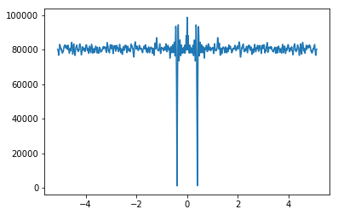
圖 1 HW 8-1
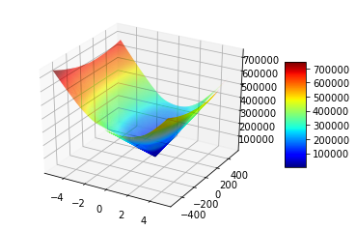
圖 2 HW8-2
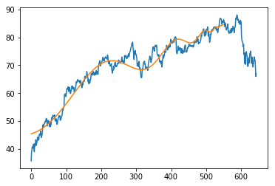
圖 3 HW8-3
Best Parameters:
tc: 551.0
beta: 0.996108949416
omega: 7.0
phi: 0.100698463349
A: 84.7564261875
B: -0.0573502752424
C: 0.290351833286
MAE: 2.00851347343

Gene code design:
tc: 6 bits, range from 550 ~ 613
beta: 8 bits, range from 1/257 ~ 256/257
omega: 4 bits, range from 5 ~ 20
phi: 6 bits, range from 0.01 ~ 63.02/2pi

